Web Services:

A Web Service is a type of API, one that almost always operates over HTTP.

Web Services are Two types: SOAP (Simple Object Access Protocol) and REST (Representational State Transfer)

**SOAP** defines a standard communication protocol, specification for XML-based message exchange.

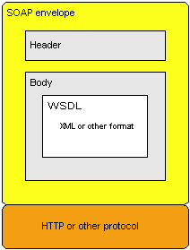

REST

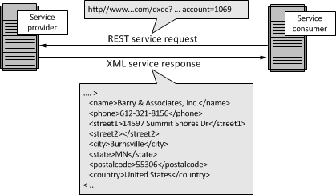

Difference between REST and SOAP

* REST API has no official standard at all because it is an architectural style. SOAP API, on the other hand, has an official standard because it is a protocol
* REST APIs uses multiple standards like HTTP, JSON, URL, and XML while SOAP APIs is largely based on HTTP and XML.
* REST API uses Web Application Description Language, and SOAP API used Web Services Description language

REST HTTP requests are:

POST – Add new data

GET – Read data

PUT – Update data that already exists

DELETE – Remove data

SoapUI supports

Envelope, Header(Option), Body

JSON: JavaScript Object Notation.

XML is much more difficult to parse than JSON.